ACCELEROMETER WITH ROBOT USING 8051 (iBOT)
Accelerometer is a device which is used for measuring the acceleration and the tilt angle of any body over which it is mounted. The output of an Accelerometer IC is in terms of variable voltage linear to the acceleration or the tilt angle. So accelerometers can used in lot of applications as two wheel balancing system, vibration sensing machine , tilting remote etc .This concept can be used in robotics wherein one can control an RC car/robot’s motion. In remote controlled robots, minimum of two axes are required; one for the forward-backward motion while the other is for left-right motion.
The Accelerometer IC (MMA7260) used in this project is sourced from Freescale Semiconductors. The wireless control transmission is achieved by using a combination of RF modules (TLP-RLP 434) with a pair of encoder decoder ICs (HT12E &HT12D).
The project makes use of the MMA7260’s voltage levels (0 to Vcc/2) corresponding to X and Y axes. Since an RC car/robot requires four channel control commands we feed these voltage levels into a set of four comparators (LM324) with reference voltages governed by the POTs R3 R4 settings and the output of these comparators are fed into the encoder IC, which in-turn sends the control command wirelessly through the transmitter module. The attached diagram depicts the schematics for the remote.
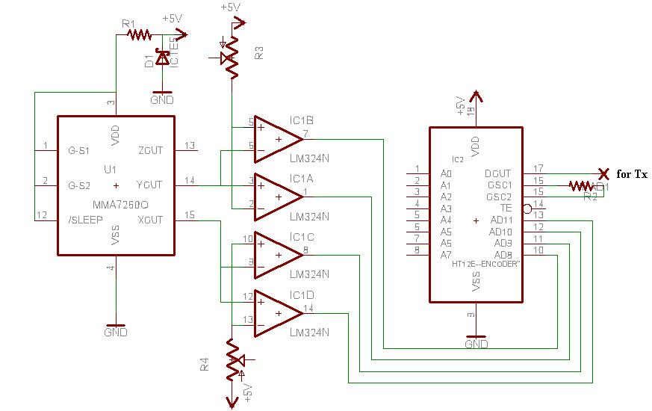
On receiver end, RF receiver module data pin is connected to decoder IC(HT12D)

WINDOW COMPARATOR

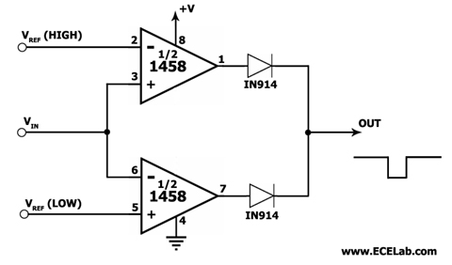
Window Comparator Circuit

This is a window comparator circuit that employs a dual op-amp IC, the 1458. This window comparator compares an input signal to a 'low' and a 'high' reference voltage level (VRef Low and VRef High, respectively), and outputs a logic low level if it falls between these two reference levels. If the input is higher than VRef High or lower than VRef Low, the output goes to logic high. One of the op amps is used for comparing the input to VRef High while the other op amp is used for comparison with VRef Low. The IN914 diodes are used to isolate the outputs of the two op amps from each other.

Using Operational Amplifiers (Op-Amps) as a Comparator

An Operational Amplifier, or Op Amp, is a dual-input, single-output linear amplifier that exhibits a high open-loop gain, high input resistances, and a low output resistance. One of the inputs of an operational amplifier amp is non-inverting while the other is inverting. The output Vout of an operational amplifier without feedback (also known as open-loop) is given by the formula: Vout = A(Vp-Vn) where A is the open-loop gain of the op amp, Vp is the voltage at the non-inverting input, and Vn is the voltage at the inverting input. The open-loop gain of a typical op amp is in the range of 10⁵-10⁶.

The operational amplifier got its name from the fact that it can be configured to perform many different mathematical operations. Depending on its feedback circuit and biasing, an op amp can be made to add, subtract, multiply, divide, negate, and, interestingly, even perform calculus operations such as differentiation and integration. Of course, aside from these operations, op amps are also found in a very large number of applications. In fact, many consider the op amp as the foundation of many analog semiconductor products today.

Because of the very high resistance exhibited by the inputs of an op amp, the currents flowing through them are very small. The current flowing in or out of an op amp's input pin, known as input bias current, is basically just leakage current at the base or gate of the input transistor of that input, which is why it is very small. When solving voltage/current equations for op amp circuits, the input currents are usually assumed to be zero. For most of the commonly-used op-amp circuits, this means that the total output current of the op amp is flowing through the feedback circuit between the output and the inverting input (the feedback is usually connected to the inverting input for operation stability).

As the main path for an op amp's output current, the feedback circuit used in an op amp largely determines how the op amp will function. There are many ways to operate an op amp, but one commonly-used basic configuration is to: 1) provide it with balanced supply voltages (say, +/-15V, although single-supply operation is also commonly used); 2) connect the non-inverting input to ground (either directly or with a passive element such as a resistor); 3) connect a feedback circuit between the output and the inverting input; and 4) connect a resistor between the inverting input and the input signal source. Figure 1 shows some op amp circuits using this basic configuration.

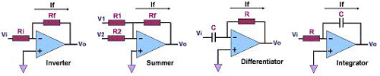
Figure 1. Some Common Operational Amplifier Circuits

Another special characteristic of a close-looped op amp with negative feedback is the zero voltage drop across its inputs. Thus, in the circuits above, the voltage at the inverting input is zero, in effect putting the inverting input at a 'virtual ground.' Table 1 shows the voltage/current equations governing the circuits in Figure 1, based on the assumptions that the currents flowing through the op amp inputs and the voltage across them are zero.

Table 1. Voltage/Current Equations for the Op Amp Circuits in Figure 1
Inverting Amplifier | Summer | Differentiator | Integrator
Vo = - If(Rf);  Vi = If(Ri);  Vo = - (Rf/Ri) Vi | Vo = - If(Rf);  If = V1/R1 + V2/R2;  Vo = - Rf(V1/R1 + V2/R2) | Vo = - If(Rf);  If = C dVi/dt;  Vo = -RfC(dVi/dt) | Vo = -1/C ∫ If dt;  If = Vi/R;  Vo = -1/(RC) ∫ Vi dt;

A typical op-amp is constructed with the following parts: 1) a differential input stage, which consists of a matched pair of bipolar transistors or field effect transistors (FET's) that produce an output that's proportional to the difference between the input signals; 2) an intermediate-gain stage that amplifies the output of the differential input stage; and 3) a push-pull output stage that is capable of delivering a large current to the load, hence the small output impedance.

